String Functions

Definition:
# Source: AI Source: Provided by: [Data Path: Persons Table -> ID Column: 1, Name_En Column: Motasem Essam] -> From: [ChatGPT] on [1/26/2026]
String functions are predefined operations provided by programming languages to manipulate or process strings. These functions allow you to perform tasks like measuring length, changing case, searching, replacing, and splitting strings.

Common String Functions

1. Length
# Source: AI Source: Provided by: [Data Path: Persons Table -> ID Column: 1, Name_En Column: Motasem Essam] -> From: [ChatGPT] on [1/26/2026]
- Returns the number of characters in a string.
- Python: len(s)
- C: strlen(s)
- Example:
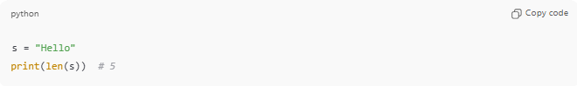
s = "Hello"
print(len(s)) # 5

2. Concatenation
# Source: AI Source: Provided by: [Data Path: Persons Table -> ID Column: 1, Name_En Column: Motasem Essam] -> From: [ChatGPT] on [1/26/2026]
- Joins two or more strings together.
- Python: s1 + s2
- C: strcat(s1, s2)
- Example:
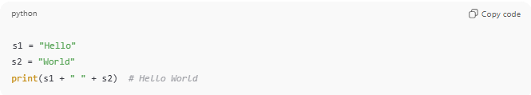
s1 = "Hello"
s2 = "World"
print(s1 + " " + s2) # Hello World

3. Copy / Assignment
# Source: AI Source: Provided by: [Data Path: Persons Table -> ID Column: 1, Name_En Column: Motasem Essam] -> From: [ChatGPT] on [1/26/2026]
- Copies a string into another variable.
- Python: s2 = s1
- C: strcpy(dest, src)
- Example:
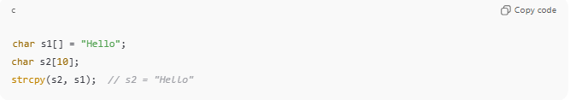
char s1[] = "Hello";
char s2[10];
strcpy(s2, s1); // s2 = "Hello"

4. Comparison
# Source: AI Source: Provided by: [Data Path: Persons Table -> ID Column: 1, Name_En Column: Motasem Essam] -> From: [ChatGPT] on [1/26/2026]
- Compares two strings to see if they are equal, or which is greater.
- Python: s1 == s2
- C: strcmp(s1, s2)
- Example:
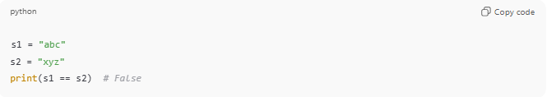
s1 = "abc"
s2 = "xyz"
print(s1 == s2) # False

5. Substring / Slicing
# Source: AI Source: Provided by: [Data Path: Persons Table -> ID Column: 1, Name_En Column: Motasem Essam] -> From: [ChatGPT] on [1/26/2026]
- Extracts part of a string.
- Python: s[0:3] → first 3 characters
- C: Use loops or strncpy()
- Example:
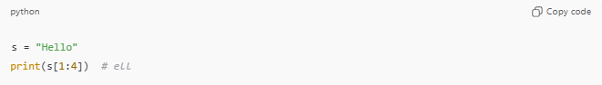
s = "Hello"
print(s[1:4]) # ell

6. Search / Find
# Source: AI Source: Provided by: [Data Path: Persons Table -> ID Column: 1, Name_En Column: Motasem Essam] -> From: [ChatGPT] on [1/26/2026]
- Finds the position of a character or substring.
- Python: s.find("lo")
- C: strstr(s, "lo")
- Example:
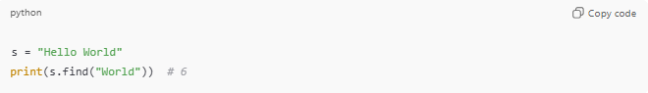
s = "Hello World"
print(s.find("World")) # 6

7. Replace
# Source: AI Source: Provided by: [Data Path: Persons Table -> ID Column: 1, Name_En Column: Motasem Essam] -> From: [ChatGPT] on [1/26/2026]
- Replaces a part of a string with another string.
- Python: s.replace("old", "new")
- Example:
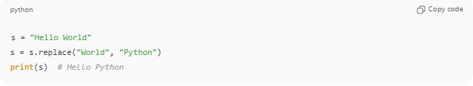
s = "Hello World"
s = s.replace("World", "Python")
print(s) # Hello Python

8. Case Conversion
# Source: AI Source: Provided by: [Data Path: Persons Table -> ID Column: 1, Name_En Column: Motasem Essam] -> From: [ChatGPT] on [1/26/2026]
- Changes uppercase to lowercase or vice versa.
- Python: s.upper(), s.lower()
- C: toupper(), tolower() for characters
- Example:
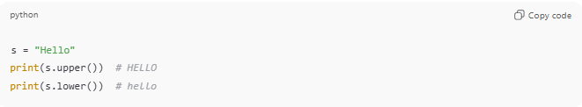
s = "Hello"
print(s.upper()) # HELLO
print(s.lower()) # hello

9. Trim / Strip
# Source: AI Source: Provided by: [Data Path: Persons Table -> ID Column: 1, Name_En Column: Motasem Essam] -> From: [ChatGPT] on [1/26/2026]
- Removes leading and trailing whitespace.
- Python: s.strip()
- Example:
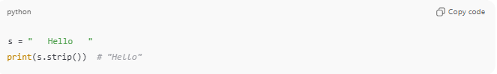
s = " Hello "
print(s.strip()) # "Hello"

10. Split / Join
# Source: AI Source: Provided by: [Data Path: Persons Table -> ID Column: 1, Name_En Column: Motasem Essam] -> From: [ChatGPT] on [1/26/2026]
- Splits a string into parts or joins a list of strings.
- Python:
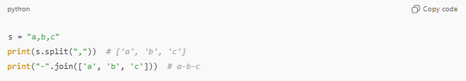
s = "a,b,c"
print(s.split(",")) # ['a', 'b', 'c']
print("-".join(['a', 'b', 'c'])) # a-b-c

Analogy
# Source: AI Source: Provided by: [Data Path: Persons Table -> ID Column: 1, Name_En Column: Motasem Essam] -> From: [ChatGPT] on [1/26/2026]
- String functions → Tools in a toolbox
- Strings → Materials you work with
- Functions help cut, join, measure, or modify the material

✅ Summary
# Source: AI Source: Provided by: [Data Path: Persons Table -> ID Column: 1, Name_En Column: Motasem Essam] -> From: [ChatGPT] on [1/26/2026]
- String functions are built-in operations for strings
- Common tasks: length, copy, concatenate, compare, search, replace, split, join, case conversion
- Supported in Python, C, C++, Java with slight syntax differences

If you want, I can make a visual table of the most important string functions with examples, which makes it easy to memorize for exams.
Do you want me to make that table?

